English Language
Paper 1

EDUQAS

Reading FICTION

Revision Guide

Name: …………………………………………………………………………………

1

Contents

Section A: Reading p3

Section A: Examination Requirements p3

Reading tips and strategies p3

Sample exam – OBED p4

Answering 5 mark HOW question p7

Answering 10 mark HOW question p10

Answering IMPRESSIONS question p13

Answering Question 5 p16

Subject Terminology p19

Example exam p20

FINAL TIPS p22

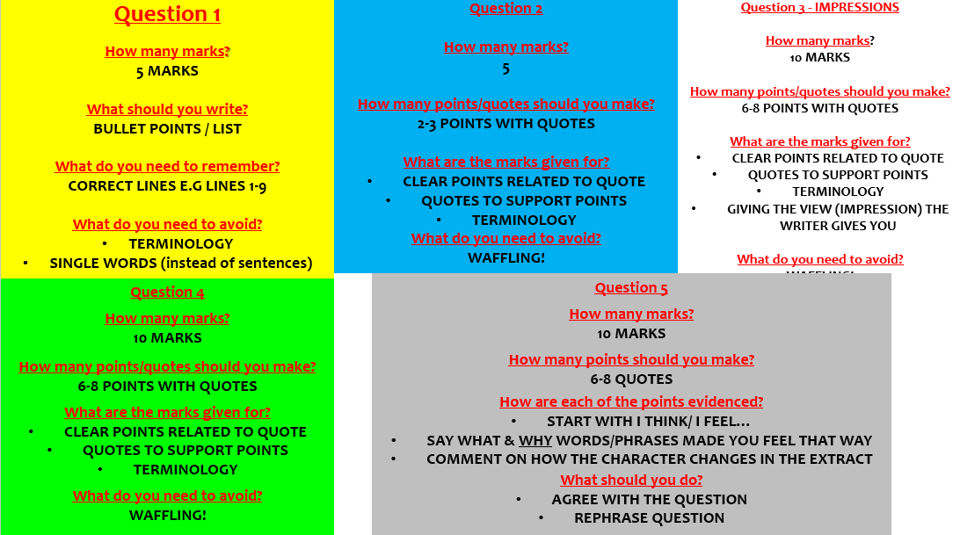

2

Section A: Examination Requirements

In this section of the exam, you are being tested on your ability to read and understand a piece of 20th Century literature.

Details of the exam are as follows:

- Section A of the paper
- Worth 20% of your whole English Language qualification
- 1 hour should be spent on this section
- You are given 1 unseen extract 1900-1999
- You have 5 questions to answer in total

- 10 minutes of the time should be spent on reading and understanding the extract
- 50 minutes should be spent on answering the questions

The questions will follow this pattern:

- Q1 - Simple retrieval type question (easy points to gain)

- One question on the ‘IMPRESSION’ you get of something.

- ‘HOW DOES THE WRITER…?’ There will be two questions on writer’s technique.

- Q5 EVALUATION: saying how much you agree with the statement in the question.

3

SECTION A: READING

Spend ONE hour on this section. Read the questions first and then look at the text to find the evidence to help you build an answer. As a handy guide, a 10 mark question should take you 13 minutes in total.

So, let’s have a look at a past paper and how to answer each of the questions.

4

5

Answering Question 1

Key information about Question 1:

  - 5 marks available

  - 5 minutes
  - Only answer from lines from the lines stated e.g. lines 1-9
  - You need to find info in a small section of the text
  - Will normally be a list question (bullet points)
  - You DO NOT need PEE.

- Only read the lines stated e.g. lines 1-9

- Highlight/underline the key words in the question.

- Read the question twice.

- Start sentences with He/she or the character’s name e.g. Obed…

- A short (very short!) sentence for each one is enough to get the marks. See the answer below as an example:

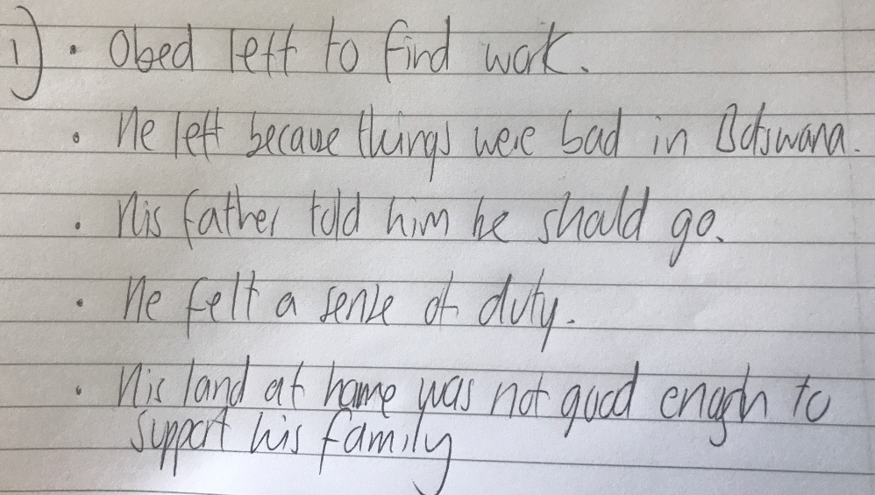

6
TASK
Now it’s your turn. Answer these two separate exam questions and make sure you get 5 out of 5.

- Megan thinks
- She thinks
- Megan feels
- She
- Megan

- Justo…
- He…
- He…
- Justo…
- Justo…
7

Answering the ‘HOW’ questions – 5 marks

Key information about the HOW questions:

  - It will ask you about writers’ craft (methods and techniques used)
  - This is a ‘HOW’ question. They are easy to spot as they’ll have ‘How’ written at the start.
  - There will be two ‘HOW’ questions.
  - It can be question 2, 3 or 4.

  - 5 marks = 5-6 minutes

Read Question 2 very carefully – twice. Highlight/underline the key words in the question.

Think: what am I being asked to do? In the question above, you are finding word or phrases that show the things Obed went through to become a miner.

Read the text again, looking for the information required for Question 2.

Find 2-3 short phrases you can talk about in your response.

In order to show that you are ‘tracking through’ the text, find:

  - 1 phrase from the start

  - 1 phrase from the middle
  - 1 phrase from the end

- You need the following to do well on this question:

  - 2-3 short phrases
  - Subject terminology (word classes, language devices, structural devices)
  - Effects on the reader

  - PEE sentences

EXAMPLES OF SUBJECT TERMINOLOGY
8
- Construct your response for Question 2.

USE THE FOLLOWING STRUCTURE X 5:

In the text, the writer [insert link to question] by using the phrase ‘___________________’, where the [insert word class/language device/structural device] creates the image of________________. This would make the reader feel _____________ because _____________.

Example PEA SENTENCES:

In the text, the writer shows what Obed went through by using the phrase ‘they made me’, where the verb ‘made’ Obed is having his choices taken away from him to become a miner.

In the final lines, the writer shows what Obed went through by using the phrase ‘took’ and ‘made’, where the powerful verbs shows that Obed has given up control of his life to become a miner.

9

Answering the ‘HOW’ questions – 10 marks

Key information about the HOW questions:

  - It will ask you about writers’ craft (methods and techniques used)
  - This is a ‘HOW’ question. They are easy to spot as they’ll have ‘How’ written at the start.
  - There will be two ‘HOW’ questions.
  - It can be question 2, 3 or 4.
  - 10 marks = 13-15 minutes

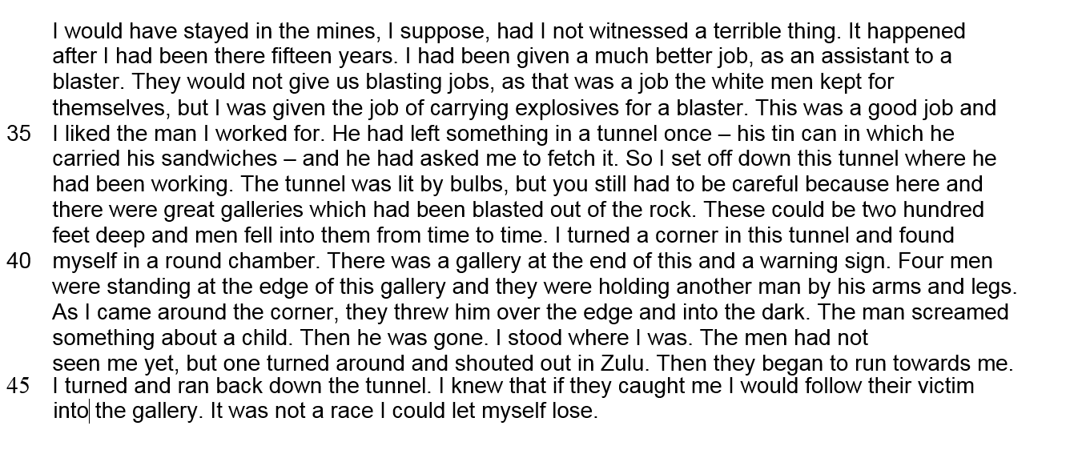

Read the question very carefully – twice. Highlight/underline the key words in the question.

Think: what am I being asked to do? In the question above, you are finding word or phrases that make the extract seem tense and dramatic.

Read the text again, looking for the information required for Question 2.

Find 5-6 short phrases you can talk about in your response.

In order to show that you are ‘tracking through’ the text, find:

  - 2 phrases from the start

  - 2 phrases from the middle
  - 2 phrases from the end

- You need the following to do well on this question:

  - 5-6 short phrases
  - Subject terminology (word classes, language devices, structural devices)
  - Effects on the reader

  - PEE sentences

EXAMPLES OF SUBJECT TERMINOLOGY

10
  - Construct your response for Question 2.

USE THE FOLLOWING STRUCTURE X 5:

In the text, the writer [insert link to question] by using the phrase ‘___________________’, where the [insert word class/language device/structural device] creates the image of________________. This would make the reader feel _____________ because _____________.

Example PEA SENTENCES:

In the text, the writer makes it tense and dramatic by using the phrase ‘had I not witnessed a terrible thing’, where the verb ‘witness’ suggests something criminal has happened and that Obed can only stand and watch.

In the text, the writer makes it tense and dramatic by using the phrase “200 feet deep and men fell into from them time to time”, where the statistic describes the scale of the tunnel and a huge drop that would kill anything.

Think you can do the same? Have a go at writing your own answer!!

11
Think you can do the same? Have a go at writing your own answer based on this extract:

In the text, the writer shows how the fire is becoming serious by using the phrase ‘abandoned, forgotten iron, where the adjectives suggest the iron has been deserted and the family have no idea where it is. This makes the iron a dangerous presence which will cause a problem to the Lennox family.

In the text, the writer shows his pain by using the phrase ‘___________________________ ’, where the _________________________________ creates the image of______________________________. This would make the reader feel _____________ because _____________________________________.

In the text, the writer shows his pain by using the phrase ‘___________________________ ’, where the _________________________________ creates the image of______________________________. This would make the reader feel _____________ because _____________________________________.

In the text, the writer shows his pain by using the phrase ‘___________________________ ’, where the _________________________________ creates the image of______________________________. This would make the reader feel _____________ because _____________________________________.

In the text, the writer shows his pain by using the phrase ‘___________________________ ’, where the _________________________________ creates the image of______________________________. This would make the reader feel _____________ because_________________________ _____________.

12
Answering the ‘IMPRESSIONS’ question – 5 OR 10 marks

Key information about the IMPRESSIONS questions:

  - It will ask you about writers’ craft (methods and techniques used)
  - It can be question 2, 3 or 4.

  - 5 marks = 5-6 minutes / 10 marks = 13-15 minutes

IMPRESSIONS means the kind of view YOU might have of the place or person when you read what is said about them.

Examples: HAPPY, BRAVE, SCARED, COMPETITIVE, NEGATIVE, SELFISH etc.
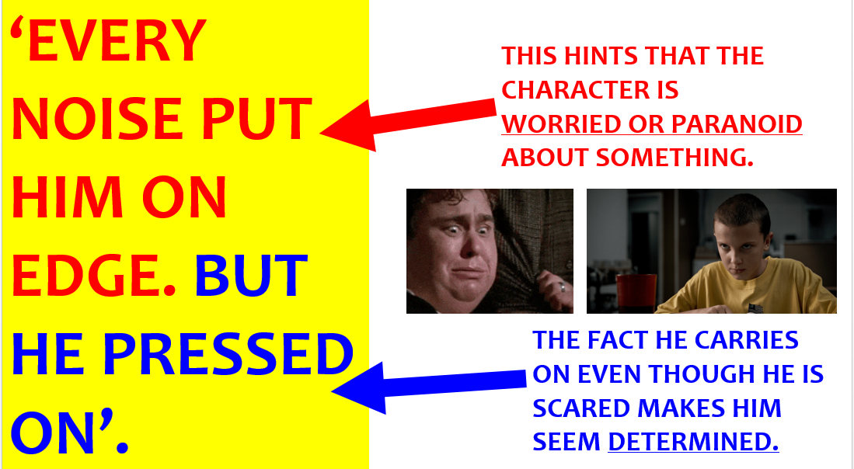

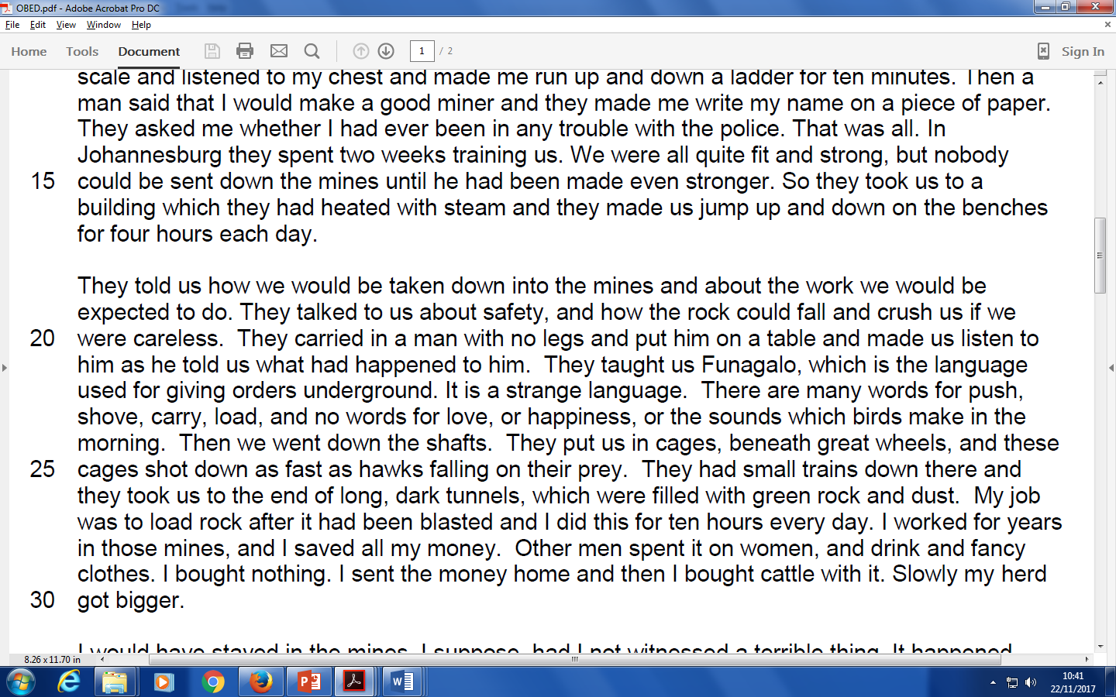

Think: what am I being asked to do? In the question above, you are giving your opinion / view on what the work in the mines is like and finding words or phrases that tell you that.

13
Read the text again, looking for the information required.

Find 5-6 short phrases you can talk about in your response.

In order to show that you are ‘tracking through’ the text, find:
  - 2 phrases from the start

  - 2 phrases from the middle
  - 2 phrases from the end

- You need the following to do well on this question:

  - 5-6 short phrases
  - Subject terminology (word classes, language devices, structural devices)
  - The impressions / view you get

  - PEE sentences

In the text, the writer gives me the impression that working in the mines is __________________________ by using the phrase ‘___________________’, where the [insert word class/language device/structural device] creates the image of________________. This would make the reader feel _____________ because _____________.

In the text, the writer gives me the impression that working in the mines is dangerous by using the phrase ‘crush the men’, where the verb ‘crush’ creates the image of the mines being incredibly powerful and able to cause the men horrific agony.

In the text, the writer gives me the impression that working in the mines is challenging by using the phrase ‘it is a strange language’, where the adjective ‘strange’ suggests the new language did not come easily to the men and they had to use their minds as well as their bodies in the mines.

In the text, the writer gives me the impression that working in the mines is unhealthy by using the phrase ‘long, dark tunnels, which were filled with green rock and dust.’, where the verb ‘filled’ suggests the tunnel’s dust is unavoidable and will affect the men’s health.
Think you can do the same? Have a go at writing your own answer based on this extract:

- What are your impressions of Jackson in these lines?
- How does the writer show you what he is like?
You must refer to the text to support your answer, using relevant subject terminology. [10]

In the text, the writer gives me the impression that Jackson is __________________________ by using the phrase ‘___________________’, where the [insert word class/language device/structural device] creates the image of________________. This would make the reader feel _____________ because _____________.

15

Answering Question 5– 10 marks

Key information about Question 5:

  - Will be worded ‘How far do you agree with…’ or ‘Evaluate…’
  - Always agree with the statement in the question
  - 10 marks = 13-15 minutes
  - You do not need to use terminology e.g. nouns, similes, adjectives etc.
  - Start each point with ‘I think…’ or ‘I feel…’

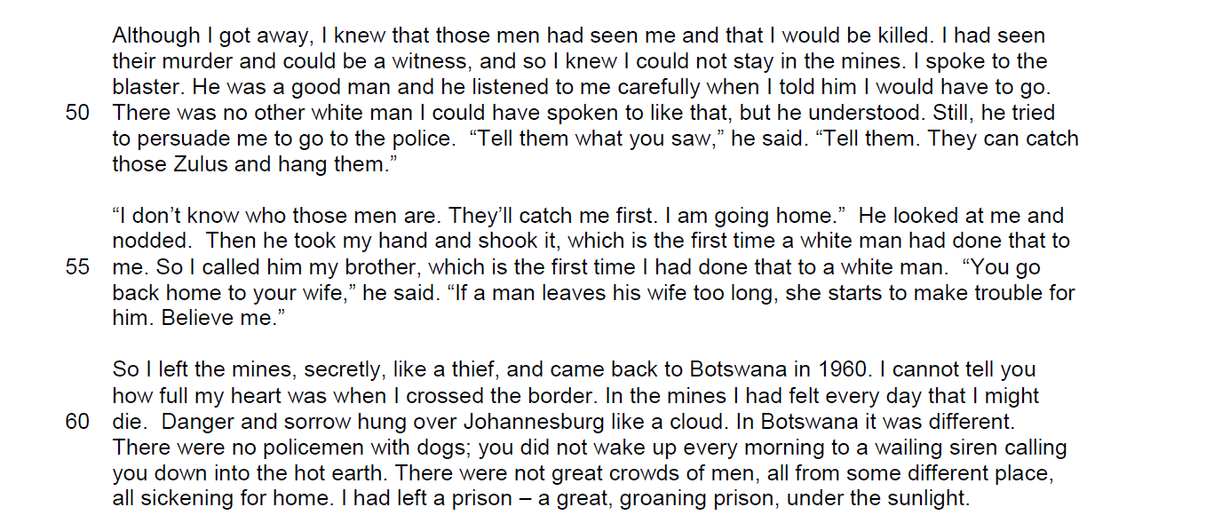

Think: what am I being asked to do? In the question above, you are discussing whether you feel sympathy for Obed.

Read the text again, looking for the information required for Question 2.

Find 5-6 short phrases you can talk about in your response.

In order to show that you are ‘tracking through’ the text, find:

  - 2 phrases from the start

  - 2 phrases from the middle
  - 2 phrases from the end

16
SAMPLE ANSWER

I feel sorry for Obed when he says ‘I would be killed’ meaning Obed is in fear of his life.

We also feel sympathy as Obed has had to give up his job and livelihood ‘I could not stay in the mines.’ We also feel Obed has suffered racism ‘there was no other white man I could have spoken to like that’ but we feel happy that at least he has found one white man who is concerned his welfare and tells him to call the police ‘Tell them…hang them.’

We feel sympathy that Obed feels he cannot wait for the police to sort it. ‘They’ll’ suggests Obed is certain the men will catch him. However, the reader feels pleased that Obed is going ‘home.’ The reader also feels pleased that Obed has experienced something unique in his life i.e. a white man he calls his ‘brother.’

We feel sympathy that Obed had to leave the country ‘like a thief’. This simile is ironic as Obed simply witnessed a crime, not committed one. We feel happiness for Obed as he says his heart is ‘full’ meaning he is almost bursting with joy.

We feel sympathy when he says ‘I had felt every day I might die’ which makes the reader sympathy because he lived for fifteen years in constant terror. The whole description of Johannesburg in the final paragraph makes us feel Obed had an awful time as he felt like he was ‘groaning prison’ and was ‘sickening for home.’ However, we feel sympathy and hope in equal measure for Obed as we know he has broken free of the ‘hot earth’ and will return home.

When we first meet him we feel sympathy that he had to leave his home country ‘proud I was born in Botswana’, his working conditions ‘long, dark tunnels filled with green rock and dust’ and the murder he witnessed ‘they threw him over the edge and into the dark.’ However, by the end of the whole extract Obed is a very different person in my eyes. He is evolves from sympathetic and persecuted, to free and home.

17
Think you can do the same? Have a go at writing your own answer based on this extract:

REMEMBER:

  - Always agree with the statement in the question
  - 10 marks = 13-15 minutes
  - You do not need to use terminology e.g. nouns, similes, adjectives etc.
  - Start each point with ‘I think…’ or ‘I feel…’

18
Subject Terminology

For Q2, Q3 & Q4, it is crucial that you include and analyse subject terminology where possible.

‘Subject terminology’ refers to the specific words we use in English.

Use the glossary below to help you learn the key terms.

Non-fiction specific language devices (AFOREST)
 | AFOREST devices |  | Definition |  | Example
 | Alliteration |  | Beginning two or more words |  | Happy Harry hollowed in the
 |  |  | with the same letter |  | darkness.
 | First person |  | Involving the speaker |  | I, me, my
 | Facts |  | Something that cannot be |  | The trip lasted six months.
 |  |  | challenged
 | Opinions |  | A personal view |  | You will regret it if you don’t
 |  |  |  |  | work hard in school
 | Rhetorical question |  | A question that does not require |  | Who do you think you are?
 |  |  | an answer
 | Repetition |  | Repeating a word, idea or |  | Stop, stop stop!
 |  |  | phrase
 | Emotive language |  | When the reader feels moved |  | Children are dying because they
 |  |  |  |  | are malnourished
 | Exaggeration/hyperbole |  | Exaggeration for deliberate |  | I was so hungry I could die!
 |  |  | effects
 | Statistics |  | Using percentages and figures |  | 88% of students have a mobile
 |  |  |  |  | phone
 | Second person |  | Direct address |  | You know how to do it!
 | Superlative |  | The most a word can be |  | Smallest, tallest…
 | Rule of three |  | Using 3 of something for effect |  | I felt lost, alone and scared.
Simile |  | Describing something using like |  | As tall as a skyscraper
 |  | or as
Metaphor |  | Describing something directly, |  | I am a beast!
 |  | not meant literally
Personification |  | Applying human characteristics |  | The tower stood tall and proud
 |  | to inanimate objects
 |  |  | Word classes
 | Word class |  | Definition |  | Example
 | Adjective |  | Describing word |  | The red car
 | Adverb |  | Describes the verb, ends in ‘ly’ |  | A ran quickly.
 | Noun |  | A person, place or thing |  | Table, chair, England
 | Verb |  | A doing word |  | He slept alone
 | Pronoun |  | First person – involves the |  | I, me, my, ours, we
 |  |  | speaker
 |  |  | Second person – direct address |  | You, yours
 |  |  | Third person – distant narrator |  | He, she, her, his, they

EXAMPLE PAPERS ON NEXT PAGE
19

FINAL EXAM TIPS!

- Do not be ‘put off’ by unfamiliar vocabulary

- Don’t pick the word!
It might sound silly, but if there are some words you cannot work out, leave them alone and get on with the exam. When you are choosing your ‘short phrases’ for your responses, choose words that you do know the meaning of.

- Q1 & Q3 – leave a 1 mark question if you can’t find it. Go back to it at the end of the exam!

- TIME MANAGE!
You must finish the exam so practise your time management.

