Component 2 Writing Exam

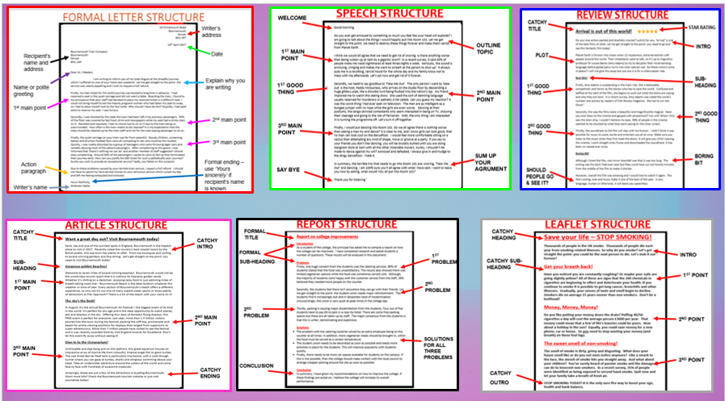

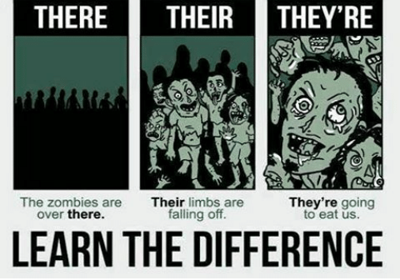

Key Points to Remember
- You need to write two documents in one hour.
- Each piece should take 25 minutes to write.
- The writing exam is worth 40 marks & each question is worth 20 marks.
- On each question, 12 marks for content & 8 for SPAG.
- Each piece should be about two sides long.

You will be asked to write two of the following:

Teacher Tips!
- Include a plan.
- Check your there/their/they/re, capital letters and apostrophes.
- Make it interesting to read: DAFOREST, sentence starters etc.
- No sentences more than 3 lines on your page of A4.
- Be clear! Make one point per paragraph (not lots of points in one big chunk!)
- Sound like you care. Don’t sit on the fence. Engage with the tasks and write something the examiner will be pleased to read.
- INTROS – for your opening paragraph, copy out parts of the exam question to help you. Look at the examples in this pack to see how easy it is!

Letters

- If you know the person’s name: - start with “Dear (person’s name)”
- end with “Yours sincerely”
- If you do not know the person’s name: - start with “Dear Sir/Madam
- end with “Yours faithfully”
- Capital letters for addresses
- Use DAFOREST – make up stats e.g. 86% of passengers disliked your service.
- Use sentence starters e.g. firstly, secondly, finally, however etc.

Your turn! Write a letter
for this exam question

Letter example – train complaint
10 Christchurch Road
Bournemouth
Dorset
BH1 3ET

10th April 2017
Bournemouth Train Company
Bournemouth
Dorset
BH1 1AP

Dear Sir / Madam,

I am writing to inform you of my total disgust at the dreadful journey which I suffered on one of your trains last weekend. Let me get straight to the point: the service was utterly appalling and I wish to request a full refund.

Firstly, my train ticket for this awful journey was booked a long time in advance. I had reserved a seat in the quiet carriage and did not want a table. Boarding the train, I found to my annoyance that your staff had decided to place my reserved ticket in a different seat. I could not bring myself to ask the heavily pregnant woman who had taken my seat to swap, so I had to place myself next to the foul toilet. Why should I have do this? Stupidly, I had paid extra to reserve my seat. I was furious.

Secondly, I was shocked by the state the train had been left in by previous passengers. 95% of the floor was covered by fast food, drink and newspapers while my seat had a stinky stain on it. Revolted and repulsed, I had no choice but to sit on it due to the train being so overcrowded. How often is the train meant to be cleaned? It is my expectation that the mess should be cleaned up by the train staff and not for the next paying passenger to sit on.

Finally, the quiet carriage on your train was far from peaceful. Rowdy children, screaming babies and drunken football fans were all competing to see who could be the loudest. Quickly, I was rudely disturbed by a group of teenagers who were throwing lager cans and verbally abusing most of the patient passengers. Around 50% of the passengers I spoke to were so fed up they terminated their journey early. How can you justify the £85 ticket for such a pathetically poor journey? Surely, you wish to provide an exceptional service? Sadly, you failed on this occasion.

Due to these problems caused by your terrible train service, I expect a full refund. I should not have to spend my hard earned money on your atrocious service which ruined my day and left me feeling exhausted and stressed.

Yours faithfully,
Ambreen Sadiq

Reports

- A report is a formal document that gives information or advice.
- Your report will be for the college or a local company.
- So...you are writing to a person you don’t know and they will act upon what you say!
- You need to be formal so be polite, use connectives (however, therefore, firstly etc.)

- Use a formal heading and subheadings
- Intro – say what you are going to do and how.
- Problems – write three problems with the centre e.g. swimming pool, café etc. Write 4-5 sentences per problem (one per paragraph)
- Solution – write a paragraph detailing how you would solve the problems e.g. employ more staff for the café.
- Conclusion – end the report suggesting the leisure centre will improve if your advice is followed.

Report example – how to improve the college
Report on college improvements

Introduction
As a student of the college, the principal has asked me to compile a report on how the college can be improved. I have completed research and asked students a number of questions. These results will be analysed in this document.

Problems
Firstly, one huge concern from the students was the catering services. 86% of students stated that the food was unsatisfactory. The results also showed there was limited vegetarian options while the food was sometimes served cold. Although, the majority of students were happy with the customer service from the staff, 26% believed they needed more people on the counter.

Secondly, the students feel there isn’t anywhere they can go with their friends. Let me get straight to the point: the student union needs major refurbishment. The students find it increasingly dull and in desperate need of modernisation. Unsurprisingly, the union is very quiet at peak times in the college day.

Thirdly, parking is causing major dissatisfaction from the students. Four out of five students have to pay £6 to park in a near-by hotel. There are some free parking spaces but these are all taken up by staff. The major consensus from the students is that this is unfair, demotivating and expensive.

Solutions
- The problem with the catering could be solved by an extra employee being on the counter at all times. In addition, more vegetarian meals should be brought in, whilst the food must be served at a certain temperature.
- The student union needs to be decorated as soon as possible and needs more activities in place for the students. This will improve popularity with students quickly.
- Finally, there needs to be more car spaces available for students on the campus. If this is not possible, then the college should make contact with the local council to arrange cheaper parking around the site as soon as possible.

Conclusion
In summary, I have given my recommendations on how to improve the college. If these findings are acted on, I believe the college will increase its overall performance.

Articles

- An article is a piece of writing included in a newspaper or magazine.
- It is written to inform, persuade and entertain the reader.
- You may hold any opinion you like, but try to be convincing in your writing.

Teacher tips!
- Create a catchy title! Use DAFOREST, alliteration, rhetorical question etc.

- Use catchy sub-headings for each point e.g. shopping could be ‘Shop till you drop!’

- Use statistics to show the reader how great your town is e.g. ‘96% of visitors say Bournemouth has the best beach in England.’

Article example – places to visit
Want a great day out? Visit Bournemouth today!
Sand, sea and one of the sunniest spots in England, Bournemouth is the hippest place to visit in 2017. Recently voted the country’s best coastal resort by the British public, this top town has plenty to offer. From hip boutiques and surfing to award-winning gardens and fine dining. Let’s get straight to the point: you need to visit Bournemouth today!
Gorgeous golden beaches!
Welcome to seven miles of award-winning beaches! Bournemouth would not be the world-class tourist resort that it is without its heavenly golden sands. Whether it’s chilling on a deckchair, enjoying tasty food or just admiring miles of breath-taking coast line – Bournemouth Beach is the ideal location whatever the weather or time of year. Every section of Bournemouth’s beach offers a different experience, so why not try out one of many superb water sports or enjoy plenty of attractions at Pier Approach? There is a bit of the beach with your name on it!
The sky’s the limit!
In August, it’s the annual Bournemouth Air Festival – the biggest event of its kind in the world. It's perfect for any age and is the ideal opportunity to watch planes, jets and displays in the sky. Offering four days of fantastic flying displays, this FREE event is perfect for everyone. Last year, more than 1.4 million visitors poured into the town during the festival, packing the cliff-top, promenade and beach for prime viewing positions for displays that ranged from supersonic to super-adventurous. More than 7 million people have visited to see the festival and it was recently awarded Gold by Visit England Awards for Excellence. Don’t let this event fly away without seeing it!
Dive-in to the Oceanarium!
Unmissable and slap-bang and on the seafront, this great aquarium houses an impressive array of marine life from colourful, tropical angel fish to giant turtles. The vast Great Barrier Reef tank is particularly impressive, with a walk-though tunnel where you can gaze at turtles, sharks and stingrays swimming above your head. Take an underwater adventure around the waters of the world and come face to face with hundreds of awesome creatures.
Amazingly, these are just a few of the attractions in bustling Bournemouth. Want more info? Check the Bournemouth tourism website or just visit yourselves today!
Reviews

- A review is a piece of writing which gives an opinion about a film, book, music, anything really!

- Try to use ambitious vocabulary e.g. absorbing, dazzling, dramatic, fascinating, imaginative, suspenseful, tragic, etc.

- Remember to include a star rating.

- Use DAFOREST to persuade the reader to see the film e.g. would you like to see the most fantastically fun film of 2018?

- Create a catchy heading (not just the name of the film) and sub-headings.

Review example of the movie ‘ARRIVAL’ (2016)
Arrival is out of this world!

Do you love action-packed and dramatic movies? Luckily for you, ‘Arrival’ is one of the best films of 2016. Let me get straight to the point: you need to go and see this fantastic film today!

Planet Earth is thrown into chaos when 12 mysterious, extra-terrestrial craft appear around the world. Their inhabitants want to talk, so it’s up to linguistics professor Dr Louise Banks (Amy Adams) to try to decipher their mind-bending language before global panic turns into inter-species war. Do these visitors come in peace? I will not give this away but you are in a for a rollercoaster ride.

Best Bits!

Firstly, Amy Adams is outstanding in the main role. She is believable, sympathetic and heroic as the doctor who has to save the world. Confused and baffled at the start of the film, she begins to work out what the aliens are saying and why they are here. In a recent survey, Amy Adams was voted the world’s number one actress by readers of Film Review magazine. She has to win the Oscar!

Secondly, the way the films looks is beautiful and magnificently magical. Have you ever been to the cinema and gasped with amazement? You will! When I first saw the alien ship, I couldn’t believe my eyes. 99% of people in the cinema seemed to be shocked by what they were seeing on the silver screen.
Thirdly, the soundtrack to the film will stay with me forever. I didn’t think it was possible for music to scare, excite and entertain you all at once. Make sure you listen to the music when they first meet the aliens. It will give you chills! Leaving the cinema, I went straight onto iTunes and downloaded the soundtrack. It has been on repeat ever since.

Boring Bit!

Although I loved the film, one minor downfall was that it was too long. The ending was the best I had ever seen but they could have cut out twenty minutes from the middle of the film to make it shorter.

However, overall the film was amazing and I would love to watch it again. The film’s acting, look and music make it one of the best of the year. In any language, human or otherwise, it will leave you speechless.

Leaflets
WRITE A LEAFLET AIMED AT PERSUADING PEOPLE TO VISIT A LOCAL ATTRACTION. [20]
M

A leaflet is a document containing information or advertising

THINGS YOU MUST DO:
- ORGANISE YOUR WRITING INTO HEADINGS AND SUB-HEADINGS

- MAKE YOUR LANGUAGE AS ENGAGING AND INTERESTING AS POSSIBLE.
- WRITE AN INTRO EXPLAINING WHAT THE LEAFLET IS ABOUT.
- 1 PARAGRAPH FOR EACH POINT YOU ARE MAKING.
- WRITE A CATCHY GOODBYE PERSUADING THE READER TO VISIT.

AVOID THESE MISTAKES!!!
- FOLDING YOUR ANSWER BOOKLET.
- INCUDING PICTURES OR COLOURS.
- NOT INCLUDING ENOUGH WRITING.

LEAFLET example - MONKEY WORLD
MONKEY WORLD!

Enjoy a fun-filled, fascinating day out for all the family at Monkey World – Ape Rescue Centre in Wareham. The park won the Dorset Tourism Awards 2017 for Guided Tour of the Year and was the Winner for Large Attraction of the Year! The 65-acre park is home to the stars of TV’s ‘Monkey Life’ and ‘Monkey Business’, and provides sanctuary for rescued and endangered primates from around the world.
Monkeying about!
As millions of visitors of Monkey World could attest, these animals are endlessly watchable. The chance to see baby orang-utans playing, lolloping bachelor chimpanzees, and acrobatic gibbons up close feels like a privilege. There are 20 species in all, while signs on the enclosures introduce you to the members of each troop and daily keeper talks reveal more about their characters. There are also two children’s playgrounds.
What about lunch and prezzies?
Feeling hungry? You’re in for a tasty treat. The main Treetops restaurant serves sausage rolls and pasties (£3), burgers and chips (£5.45) and jacket potatoes (from £3.45). Kids’ meals are £4.15. Two further cafes serve baguettes, cake and ice-cream. It’s cheap – coffee is £1.55 – but that’s not reflected in the quality. There’s also a vast array of ape-themed gifts from mugs and posters to bookends and sweets and biscuits named after the residents! Surely grandma would appreciate a packet of chimp Thelma’s butter fudge and chocolate chop shortbread?
Getting here!
North of Lulworth and west of Wareham, it’s on the A31 between Bere Regis and Wool. Trains (from London Waterloo), and the Jurassic Coast bus service, stop at Wool, 1½ miles from the park. There are so many easy ways to get to the park!
Visit the monkey kingdom today!
Speeches
You have been asked to give a talk to your class on the topic ‘Things that really annoy me.’ (20 marks)

TOP TIPS!
- Do not use fillers – um, oh etc.
- Brief welcome
- Outline topic
- One key point in each paragraph with connectives
- End with something memorable
- Use DAFOREST
- Address the audience – ‘You’ and ‘We’
- Try and persuade the reader to agree with you!

SPEECH example – things that annoy you

Good morning,

Do you ever get annoyed by something so much you feel like your head will explode? I am going to talk about the things that melt my brain. Let me get straight to the point: we need to destroy these things forever and make them vanish from Planet Earth.

I think we would all agree that we need to get rid of snoring. Is there anything worse than being woken up at 3am by a gigantic snort? In a recent survey, it said 45% of people make these nasal nightmares at least three nights a week. Seriously, the sound is annoying, cringing and makes me want to scream at the person to shut up! It always puts me in a revolting, rancid mood for the whole day and my family know not to mess with me afterwards. Let’s act now and get rid of it forever.

Secondly, we need to say goodbye to ‘Take Me Out’. The only person I want to ‘take out’ is the host, Paddy McGuiness, who arrives on the studio floor by descending a huge glittery pipe, like a showbiz turd being flushed into the nation's lap. My friend implored me to watch this dating show. She used the sort of damning language usually reserved for murderers or pathetic Z-list celebs. Can you guess my reaction? It was the worst thing I had ever seen on television. The men are as intelligent as a bungee jumper with no rope while the girls are even worse. Dancing at their podiums, the tango-skinned contestants only seem interested in being on TV, showing their cleavage and going to the Isle of Fernando. Well, the only thing I am interested in is turning the programme off. Let’s turn it off together.

Finally, I would put dancing into Room 101. Do we all agree there is nothing worse than seeing a man try and dance? It is clear to me, and I know girls can look good, that no man can look cool on the dancefloor. I would feel more comfortable sitting on a cactus than attempting any kind of shape, move or groove at a party. If you say to your friends you don’t like dancing, you will be brutally bullied until you are doing Gangnam Style at 3am with all the other miserable movers. Surely, I shouldn’t be made to dance against my will? Annoyed and defeated, I always give in and trudge to the dingy dancefloor. I hate it.

In summary, the terrible trio that need to say goodbye are the following: snoring, ‘Take Me Out’ and dancing. I am 100% sure you’ll all agree with what I have said. I want to leave you now by asking, what would YOU all put into Room 101?

Thank you for listening.

How are you going to impress the examiner?

